Ansible Homework

Rishabh Gupta

010013666

Github link: <https://github.com/Rish3095/ansible_homework>

1. All the EC2 Instances, where ansible_1 is the Ansible server.

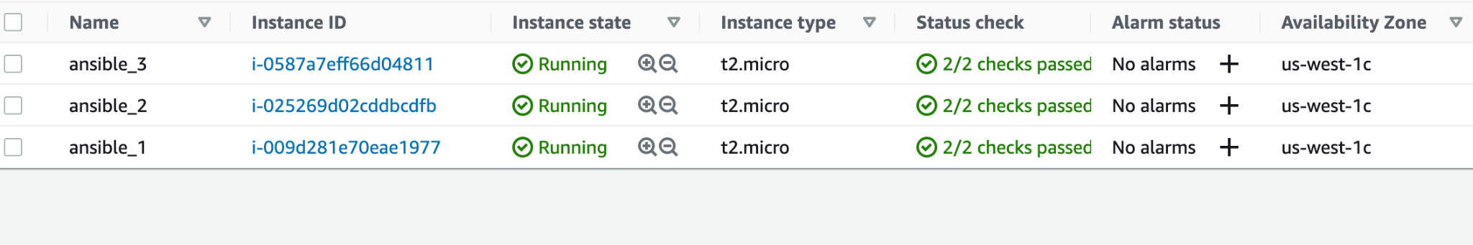

1. Inbound rules for the Ec2’s:

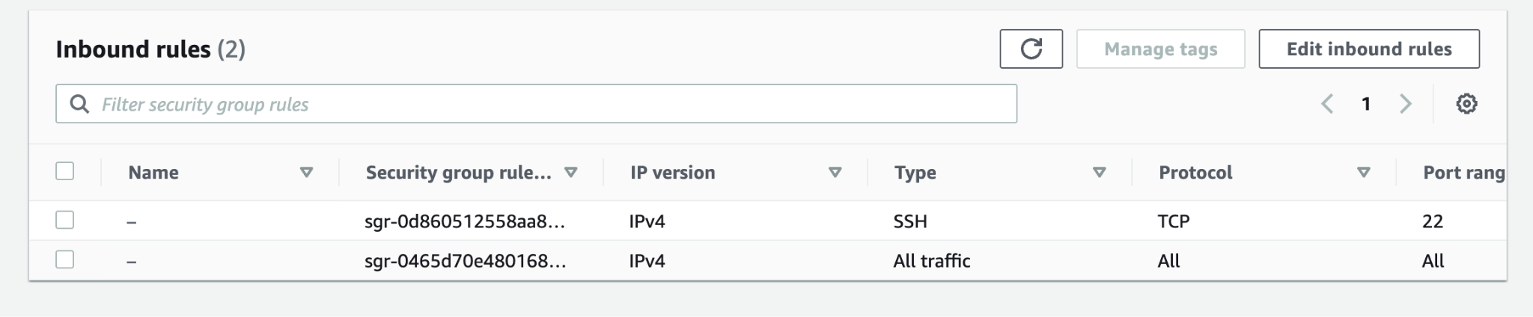

1. Used the following commands to update and download ansible:
   1. sudo apt-get update
   2. sudo apt-get upgrade
   3. sudo apt-get install ansible (install ansible)
   4. sudo passwd ubuntu (setup password access)
2. Connect ansible server to other 2 VM’s:
   1. ssh-copy-id -i ~/.ssh/id_rsa.pub ubuntu@<VM address>
3. Command to trigger deployment + Output of the deployment command:

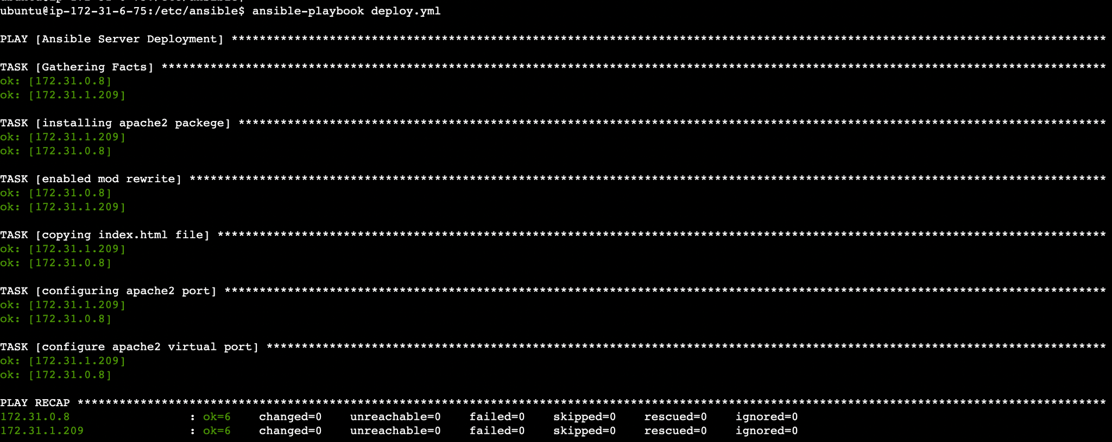

1. Screenshot 1 displaying the message:

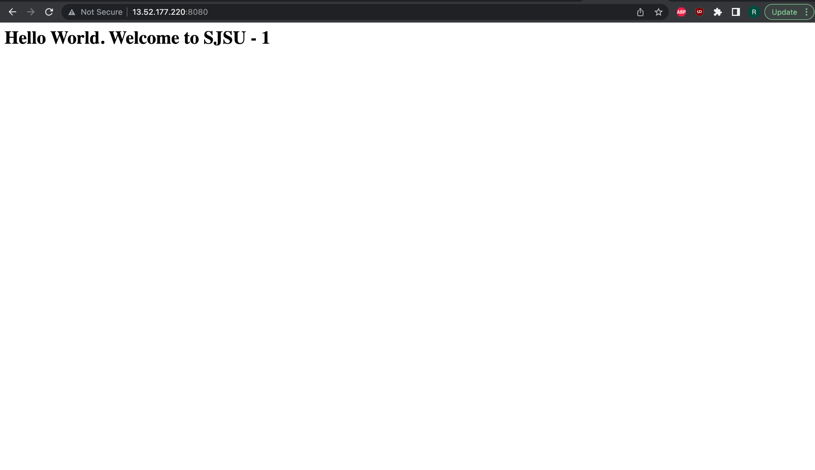

1. Screenshot 2 displaying the message:

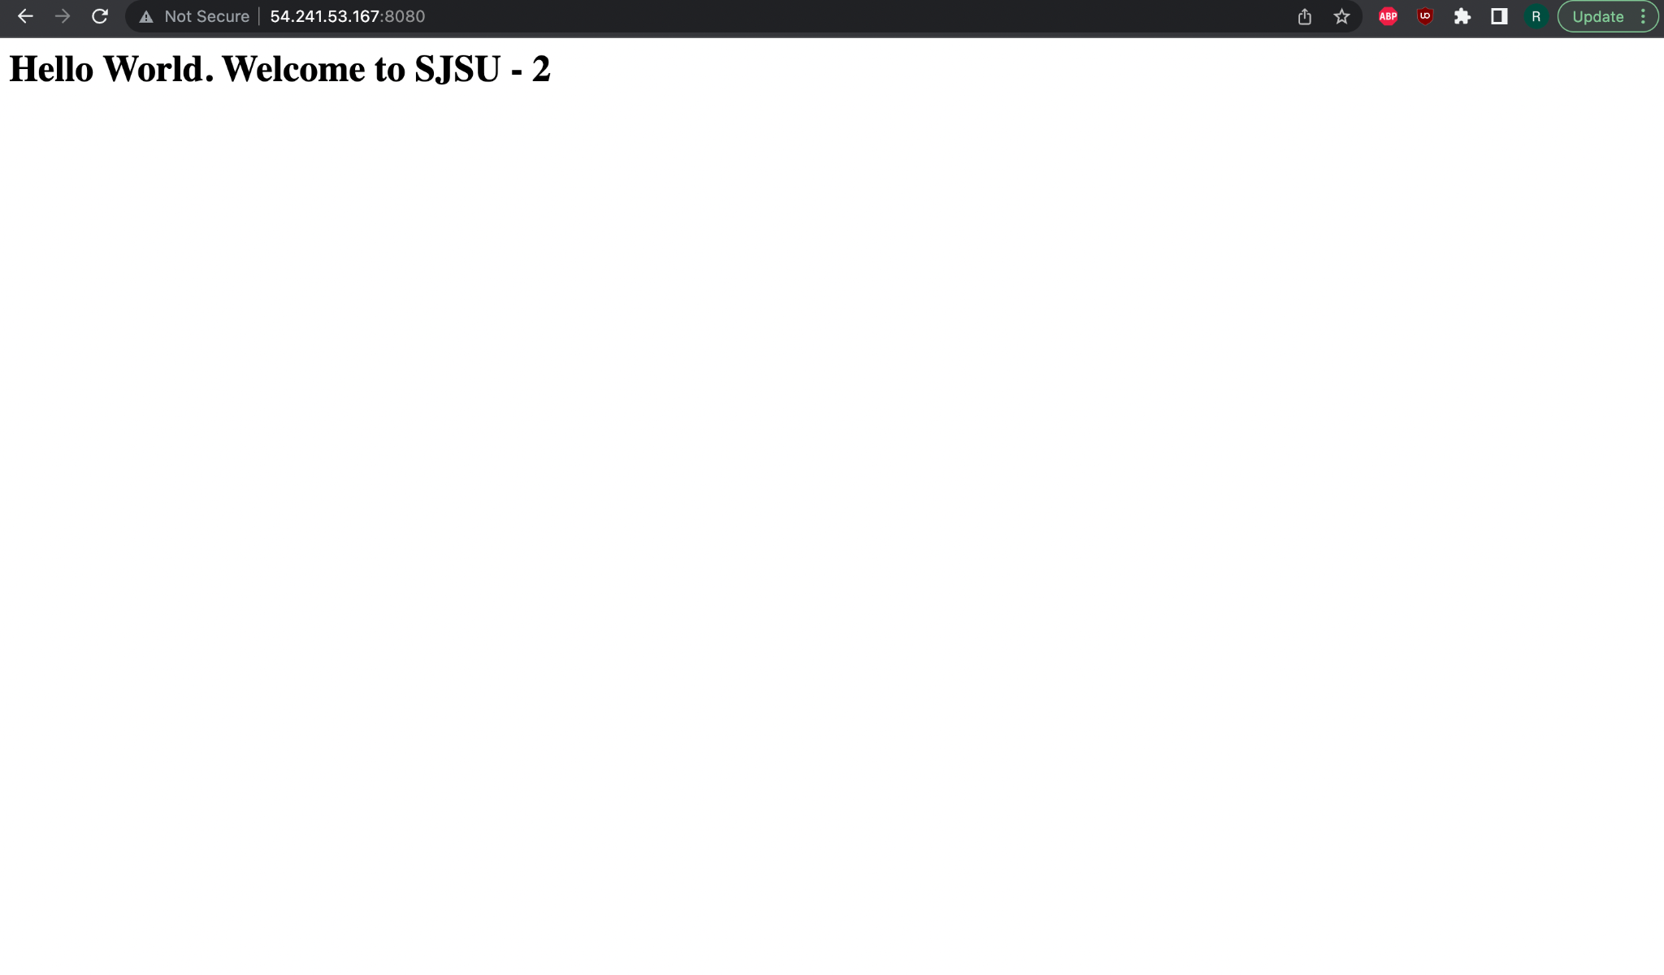

1. Triggering undeploy script + successfully trigger output:

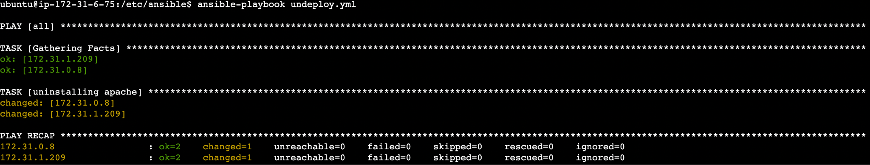

1. Screenshot of vm1 stopped:

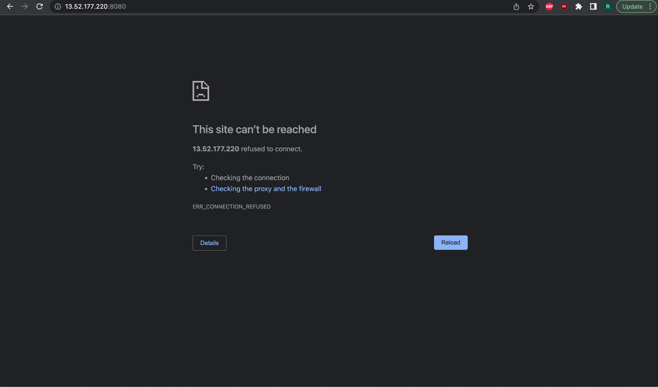

1. Screenshot of vm2 stopped:

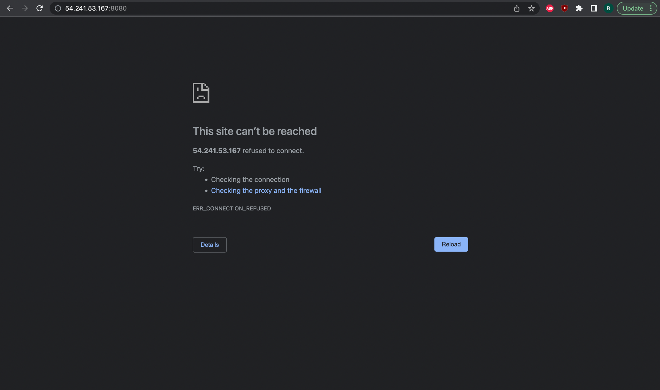

References:

<https://medium.com/@anishkhandelwal.1999/configuring-apache-httpd-web-server-on-aws-ec2-instance-using-ansible-5a6dd9a301ec>

<https://aspsqltutorials.blogspot.com/2019/10/how-to-install-apache-using-ansible.html>

<https://www.digitalocean.com/community/tutorials/how-to-use-ansible-to-install-and-set-up-apache-on-ubuntu-18-04>